

DOUGLAS COUNTY SCHOOL DISTRICT RE-1
Strategic Sourcing & Contract Management

REQUEST FOR PROPOSAL
Mowing Services - Groups 2, 5, 7 & 8

RFP Number | 003-27
Date of Issue | September 28, 2026
Proposal Closing Date | October 23, 2026, at 2:00 PM Mountain Time
Submit Via | Rocky Mountain e-Purchasing (BidNet)
Solicitation Contact | Rich Harley, Technology Procurement Strategist, rharley@dcsdk12.org

THIS IS NOT A LOW-BID SOLICITATION. DCSD will award based on overall value, considering supplier qualifications, price, products, and service capabilities — not price alone.

Proposals must be received PRIOR TO the date and time stated above.
Late proposals will not be accepted.

Sections 5.0 through 7.0 and 9.0 through 14.0 are DCSD standard solicitation conditions, except Section 13.2, which is specific to this solicitation. Standard conditions current as of 9/24/2026.
  - INTRODUCTION
  - Purpose. Douglas County School District RE-1 (“DCSD” or the “District”) requests proposals from qualified firms or individuals for mowing services for high schools and middle schools in Castle Rock, Highlands Ranch and Parker Colorado.
  - Submission. Proposals shall be submitted to the Strategic Sourcing & Contract Management Department of DCSD through Rocky Mountain e-Purchasing (“BidNet”) in accordance with all requirements of this Request for Proposal (“RFP”). Proposals will be received until the date and time stated on the cover page.
  - Contact. All questions and communications regarding this RFP shall be submitted through BidNet.
  - Effect of Award. The agreement between DCSD and the awarded Respondent, whether executed at award or already in effect, governs the relationship between the parties. Statements in this RFP or in a Response do not modify that agreement unless the parties agree otherwise in writing.

- SOLICITATION SCHEDULE
DCSD anticipates the following schedule. Dates other than the proposal submission deadline are estimates only. DCSD may modify the schedule at any time by Addendum.

Milestone | Date
RFP published | September 28, 2026
Pre-proposal site walkthrough with James Korth - Grounds Manager | October 14, 2026, 9AM  Mountain Vista High School - 10585 Mountain Vista Ridge, Highlands Ranch, CO 80126
Proposal submission deadline | October 23, 2026, 2:00 PM MT
Notice of intent to award | November 6, 2026 (anticipated)
  - Site Walkthrough. If a site walkthrough is required, DCSD will hold it at the date, time, and location stated above. A Proposal from a Respondent that did not sign in at the walkthrough will be rejected as non-responsive. Respondents shall arrive on time; DCSD is not obligated to repeat the walkthrough. Statements made at the walkthrough are informational only and do not modify this RFP.

- OBJECTIVE
Supplier to provide mowing services (mowing, trimming, edging, cleaning/sweeping, weed control, aeration and fertilization) at high schools and middle schools in DCSD group locations 2, 5, 7 & 8.

- SCOPE OF SERVICES

Mowing Sites and Square Footage

Group 2
School | Address | Turf (sq ft) | Rock Bed (sq ft) | Mulch Bed (sq ft)
Chaparral HS | 15655 Brookstone Dr, Parker, CO 80134 | 452,869 | 33,286 0 | 0
Cimarron MS | 12130 Canterberry Pky, Parker, CO 80138 | 237,664 | 4,455 | 0
Legend HS | 22219 Hilltop Road, Parker, CO 80138 | 293,538 | 19,065 | 0
Mesa MS | 365 N Mitchell St, Castle Rock, CO 80104 | 214,661 | 27,314 | 0
Ponderosa HS | 7007 E Bayou Gulch Rd, Parker, CO 80134 | 606,125 | 18,886 | 12,511
Sagewood MS | 4725 Fox Sparrow Rd, Parker, CO 80134 | 274,395 | 23,474 | 0
Sierra MS | 6651 Pine Lane Ave, Parker, CO 80138 | 218,046 | 7,278 | 1,368
VALE | 15653 Brookstone Drive, Parker, CO 80134 | 25,292 | 3,200 | 0

Group 5
School | Address | Turf (sq ft) | Rock Bed (sq ft) | Mulch Bed (sq ft)
Castle Rock MS | 2575 Meadows Blvd, Castle Rock, CO 80109 | 195,116 | 21,472 | 0
Castle View HiS | 5254 N Meadows Dr, Castle Rock, CO 80109 | 374,362 | 16,049 | 0
Douglas County HS | 2842 Front St, Castle Rock, CO 80104 | 729,103 | 42,462 | 13,050

Group 7
School | Address | Turf (sq ft) | Rock Bed (sq ft) | Mulch Bed (sq ft)
Mountain Ridge MS | 10590 Mountain Vista Ridge, Highlands Ranch, CO 80126 | 253,419 | 14,757 | 0
Mountain Vista HS | 10585 Mountain Vista Ridge, Highlands Ranch, CO 80126 | 371,979 | 36,917 | 0
Rock Canyon HS | 5810 McArthur Ranch Road, Highlands Ranch, CO 80124 | 447,941 | 42,665 | 0
Rocky Heights MS | 11033 Monarch Blvd, Highlands Ranch, CO 80124 | 252,706 | 21,832 | 0

Group 8
School | Address | Turf (sq ft) | Rock Bed (sq ft) | Mulch Bed (sq ft)
Cresthill MS | 9195 Cresthill Lane, Highlands Ranch, CO 80130 | 325,379 | 27,468 | 0
Highlands Ranch HS | 9375 S Cresthill Lane, Highlands Ranch, CO 80130 | 516,365 | 46,176 | 0
Ranch View MS | 1731 Wildcat Reserve Pkwy, Highlands Ranch, CO 80126 | 256,297 | 30,031 | 2,244
Thunder Ridge HS | 1991 Wildcat Reserve Pkwy, Highlands Ranch, CO 80129 | 534,870 | 29,431 | 1,668

General
a. Furnish all supervision, labor, materials, equipment, and transportation required to
maintain the landscape in an attractive condition throughout the school year as specified
below.
b. Check in with the site’s office before performing services.
c. All work will be done to avoid interference with normal business at the buildings and
grounds. Mowing of areas that are occupied must be scheduled around school sponsored activities.
d. All workers will dress appropriately. T-shirts with company logo will be required at all
times. As well as appropriate dress for safety.
e. All workers will use appropriate safety equipment. Safety of the people on the property
will be the first consideration for all activities. No equipment will be left running
unattended. Parking and equipment space utilization will not impede traffic patterns or
parking access by building/grounds occupants.
f. Contract period will be determined by DCSD Grounds Supervisor and will run
approximately from beginning of April (beginning of growing season) until
approximately the end of October (end of growing season). Actual start and end
dates will be determined by the DCSD Grounds Supervisor, and Supplier will be
expected to meet these dates. No more than a 3% price increase will be
considered upon renewals. No increase is preferred.
g. A monthly meeting may be led by personnel of Supplier and DCSD Grounds
Supervisor to discuss the status of contract and performance.
h. Native Mow must be completed by the last day of every month. Otherwise,
payment will be made upon completion of work.

Mowing Areas
a. All sites will be mowed in their entirety. Quantity of mowing and areas to be
mowed are the responsibility of the Supplier to verify.
b. All questions and/or clarification of mowing areas must be addressed directly to
DCSD Grounds Manager, James Korth (jpkorth@dcsdk12.org).
c. All areas shall be mowed to a height of three (3) inches during each week of the
contracted period. “A week” for the purpose of this scope of work is defined as
Monday through Sunday. All mowing will occur according to the DCSD Grounds
Manager-approved schedule each week. The schedule will be submitted ten
days prior to the start of the mowing season. The owner must agree to variations
to the specific mowing schedule when the mowing schedule is interrupted by
adverse weather conditions (including, but not limited to, rain/snow).
d. If there is inclement weather, adjustments to the mowing schedule are allowed
within the same week it was scheduled to be mowed. However, the change of
mowing date will need to be approved in advance with DCSD Grounds
Manager. The Supplier will agree to the date/method most appropriate to the
DCSD Grounds Manager, when an agreement cannot be reached between both
parties.
e. All native grass areas will be mowed once per month at all contracted sites. The
standard native mow procedures include mowing the perimeter of the
property/fence lines and all sidewalks adjacent to native grass areas with a 6-foot
beauty band at a 3-inch height. Along with the 6-foot beauty band mow, some sites will be a full native mow once a month.

Trimming
a. Trimming of all areas associated with the mowing areas will be done on a weekly
basis.
b. All trimming around structures, fences, trees, shrubs, baseball/football equipment
areas, and/or near fields and tracks, etc., is to be included.
c. Trimming will be done at the same height as the adjacent turf (three inches). Nonselective herbicides may be used as a substitute for trimming; however, prior
approval by the DCSD Grounds Manager is required.
d. All trimming shall be done with nylon weed whips. Tree trunks shall not be hit
with the mowers or power weed whips. The Supplier will replace any trees
that are damaged by trimming or mowing too close

Edging
a. Edging of all sidewalks and asphalt walkways will be done one time per month.
b. Residual debris from the edging process will be cleaned up and removed from the
site.
c. Edging with string trimmers is not acceptable.

Cleaning/Sweeping
a. All clippings will be removed from surrounding surfaces, including but not
limited to sidewalks and walkways. No visible accumulation of clippings is
allowed in gutters, parking lots, etc.
b. All fuel or oil spills of any type will be cleaned up appropriately and
immediately.
c. At the discretion of the DCSD Grounds Manager, the Supplier will remove
clippings that accumulate on the turf. Sweeping of all turf is not necessary, but
piles and swaths of excessive clippings shall be removed.
d. All grass clippings must be removed from sites.
Weed Control
a. An early pre-emergence spray is recommended to be applied in all rock areas,
mulch and shrub beds, and hard surfaces (such as sidewalks and walk paths).
b. On a weekly basis, the Supplier will inspect all rock areas, sports field weeds
(shot put/discus areas and baseball/softball warning tracks), mulch and shrub
beds, and hard surfaces and either spray or pull weeds to keep these areas weedfree.
c. All chemicals used to spray for weeds must first be approved by DCSD Grounds
Manager, James Korth.
d. Supplier must email SDS sheets to DCSD Grounds Manager, James Korth, at
jpkorth@dcsdk12.org prior to the start of the mowing season.

Inclement Weather
a. Absolutely no mowing will be allowed while rain is falling.
b. Grass will not be cut if the turf areas are saturated. DCSD officials will make the
final determination if there is a concern.

Additional Mows
a. In the event of heavy turf growth (in the months of May and August), DCSD may
request an additional mow on athletic turf surfaces.
b. The request may require one (1) additional mow per week to all baseball, soccer,
lacrosse, and softball fields until it is determined by the DCSD Grounds Manager
that additional work is no longer needed.

Additional Services
a. Aeration of all yards around the building
• Once a year in the spring
• Clean/blow all aeration plugs on hard surfaces
• Must avoid all valve boxes
b. Fertilizations of all yards around the building
• Once a year in the spring, on a no contact day.
• Product called 30-2-12 One and Done Fertilization is compatible upon DCSD
Grounds Manager approval
• Blow all granules from hard surfaces
• Prefer this to be completed on a non-contact day
• Proof of fertilization is required and must be provided to the DCSD Grounds
Manager. This can be in the form of an invoice for the purchase of the fertilizer.
c. Broadleaf
• Spraying of all blue grass. To be completed on a no contact day.
DCSD Grounds Manager will determine dates to start this one-time application.

Billing
a. DCSD shall be invoiced once per month in arrears (after services have been
provided).
4
b. Each monthly invoice shall include the following details: location name, number
of weeks serviced per location, fee per week, and total monthly cost per location.
c. Invoices may not be submitted until all work has been completed. This includes
Native Mow. Invoices shall be emailed to Jane Jenkins at
Jane.Jenkins@dcsdk12.org in order to be paid on time.

Miscellaneous
a. Turf maintenance will be completed so as not to interfere with these functions:
• School Activities
• Athletic Events
• Classroom Schedules
• Student Activities
• Student Lunch Periods, Recesses
• Sprinkler System Watering Schedules
• Fertilizing of Lawns
• Striping of Athletic Fields
• Time and dates will be provided to the Supplier for these functions at each site. It
is mandatory that the building administrator at each site be informed prior
to beginning work when school is in session.
b. All turf will be mowed at a height of three (3) inches, with blades sharpened
weekly.
c. All turf will be mowed once within a seven (7) day cycle.
d. All sidewalk/curb areas are to be edged to street entrances and the main sidewalks
one time each month.
e. All areas along turfed fence lines, areas where mowers cannot reach, such as
around trees, telephone poles, warning tracks, etc., are to be trimmed (nylon weed
whips). Tree trunks shall not be hit with the mowers or power weed whips. The
Supplier will replace any trees that are damaged by trimming or mowing too
close.
f. Excess mulch (from mowing) will be picked up and hauled away within one day
(not disposed of in DCSD dumpsters). Excess mulch to be determined by
DCSD Grounds Supervisor.
g. All sidewalks, parking lots, and driveways where excessive amounts of mulch
collect are to be blown, swept, or picked up, and hauled away.
h. Any damage to school property (including turf, trees, shrubs, sprinkler heads,
valve boxes, equipment ruts, excessive scalping) will be repaired or replaced at
the Supplier’s cost in a timely manner.
i. The mowing contract will begin and end on the dates established by the DCSD
Grounds Supervisor. The final mowing will be scheduled to clean all debris and
leaves from the site. Final payment will be made after inspection of all sites is
completed by the DCSD Grounds Supervisor.
j. The DCSD Grounds Supervisor will determine the mowing schedule during times
of drought. There may be times when weekly mowing will be skipped.

Native maps. Highlighted areas are a full mow and the highlighted lines are a 6-foot mow band.

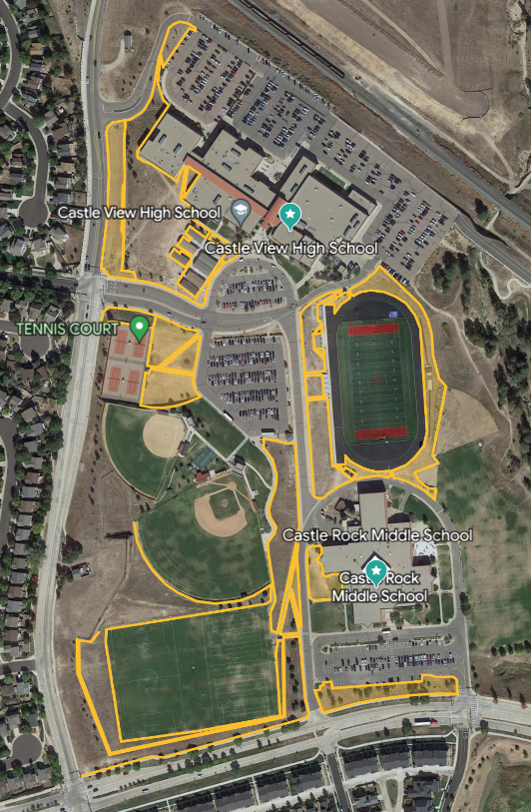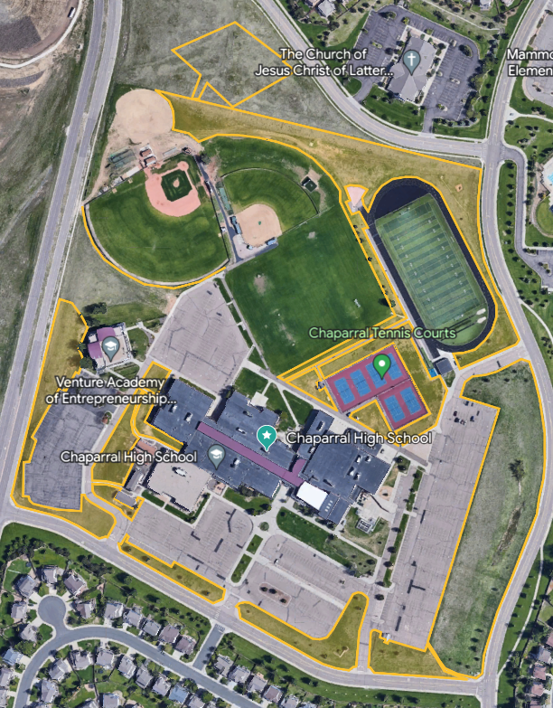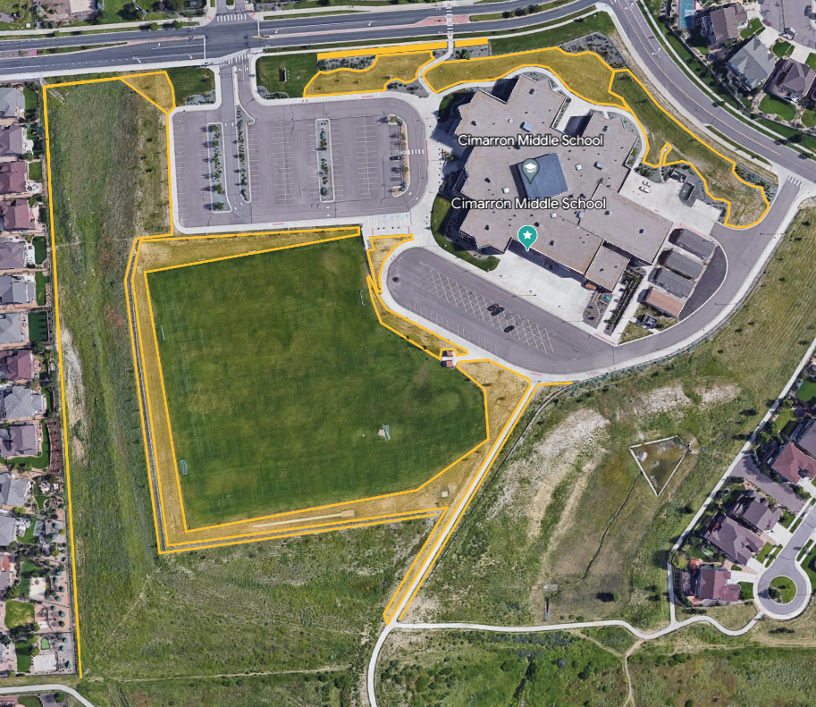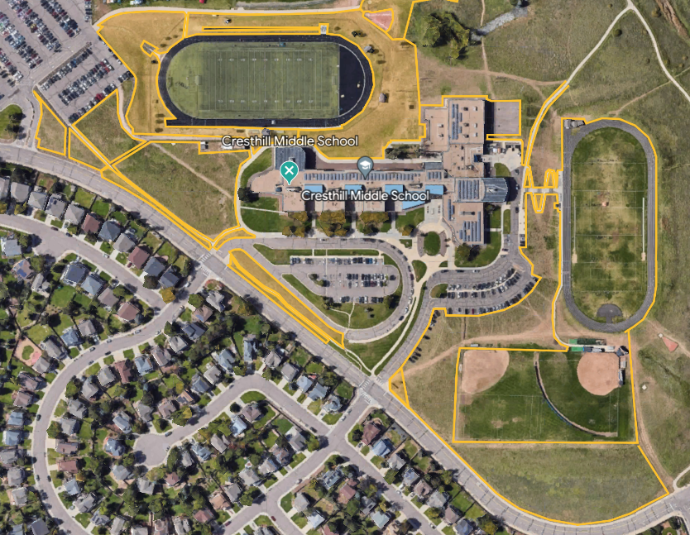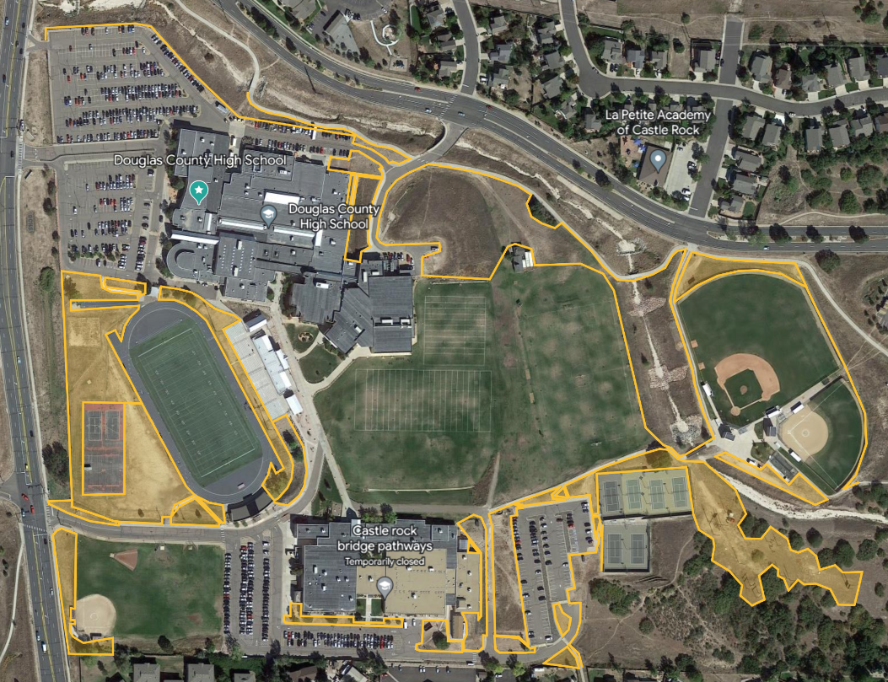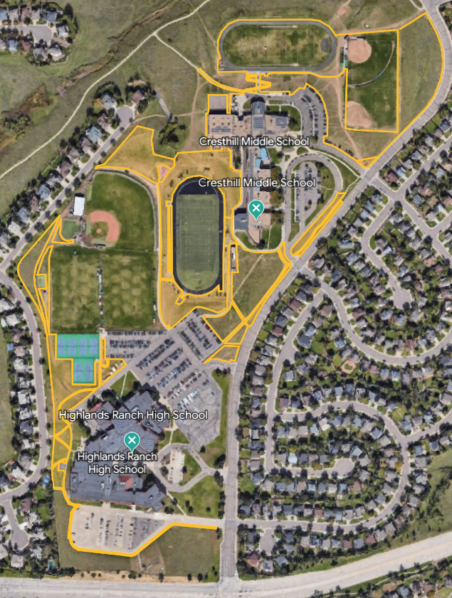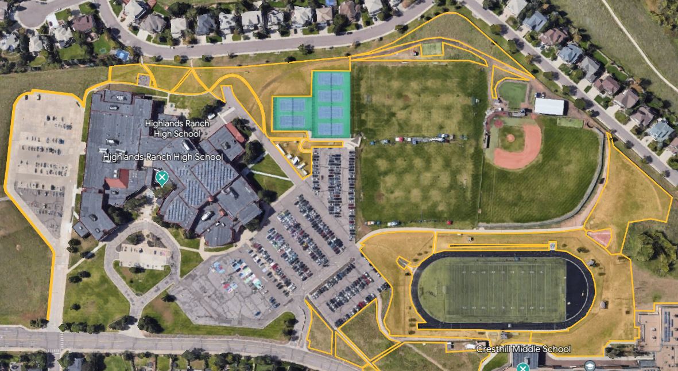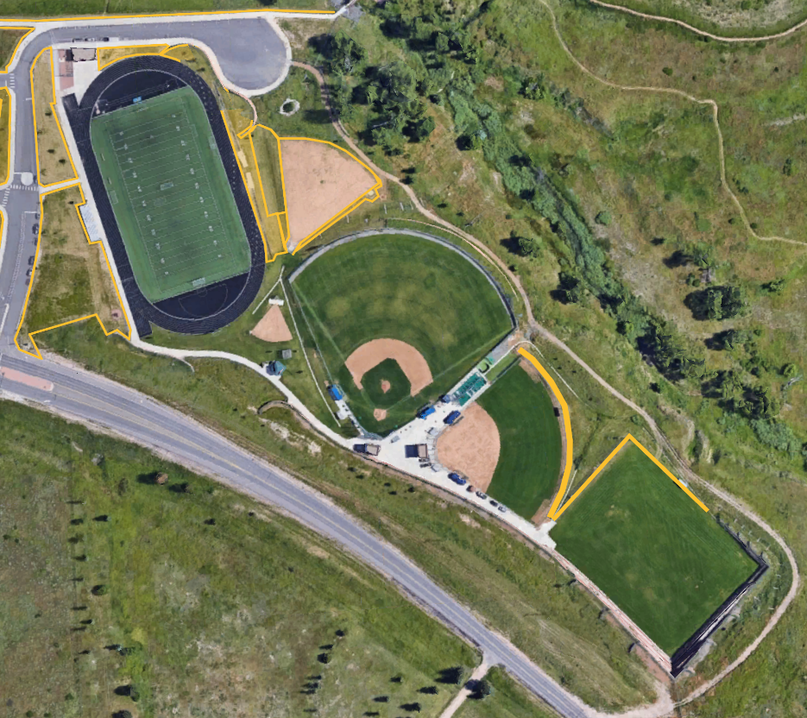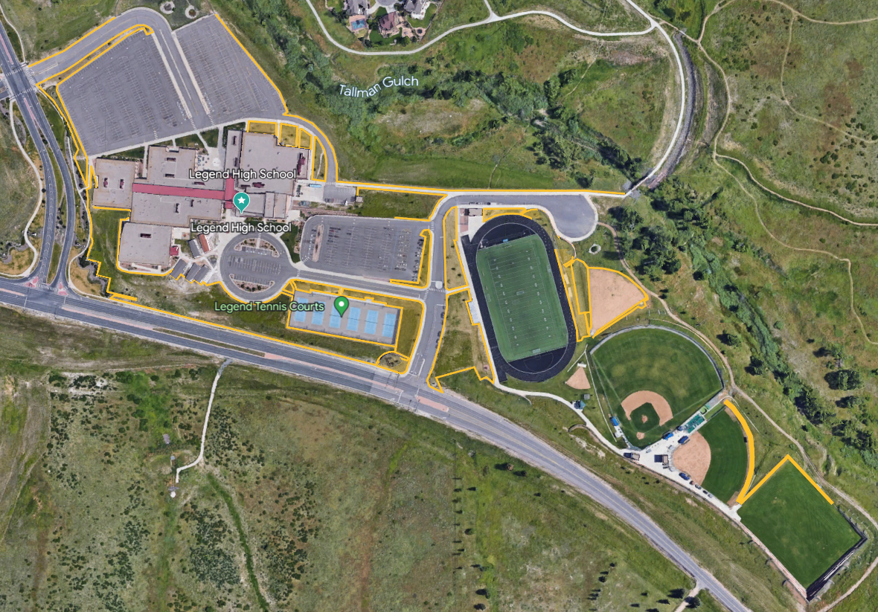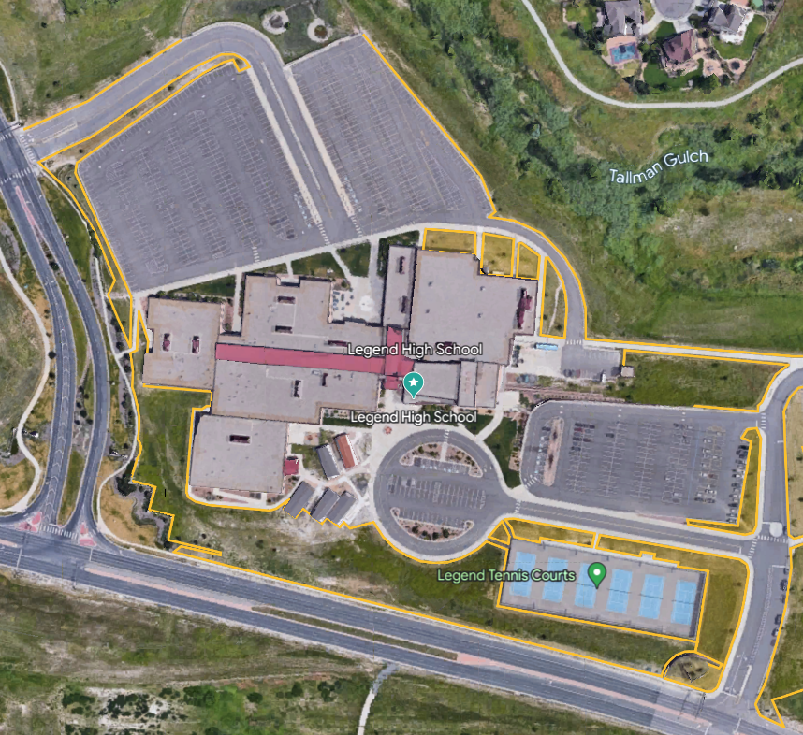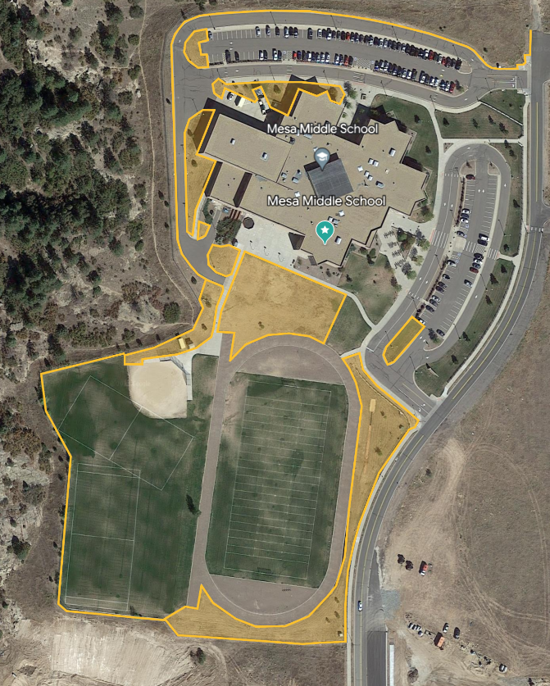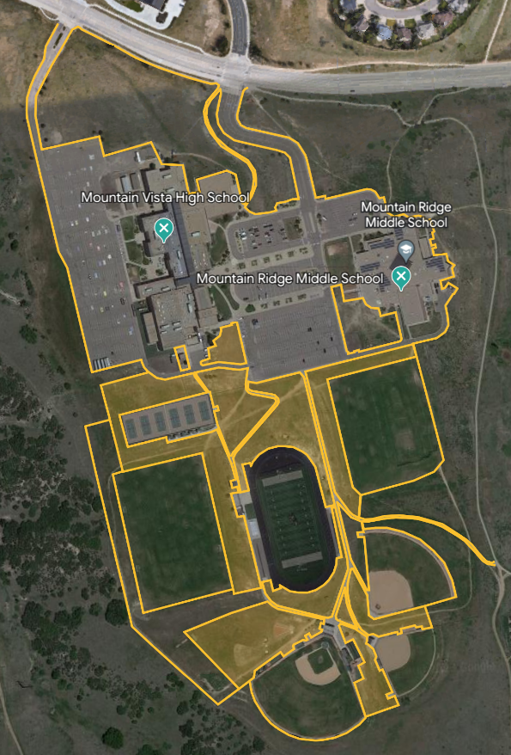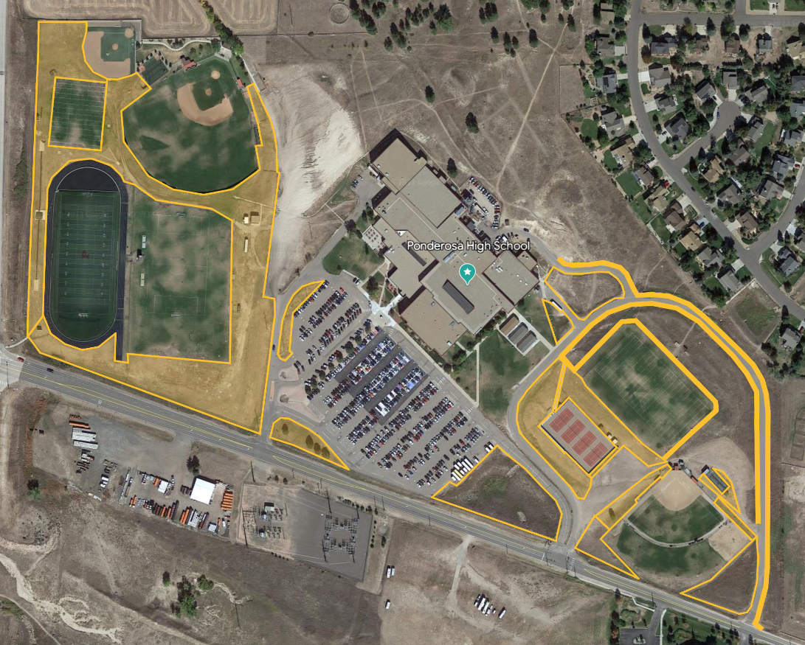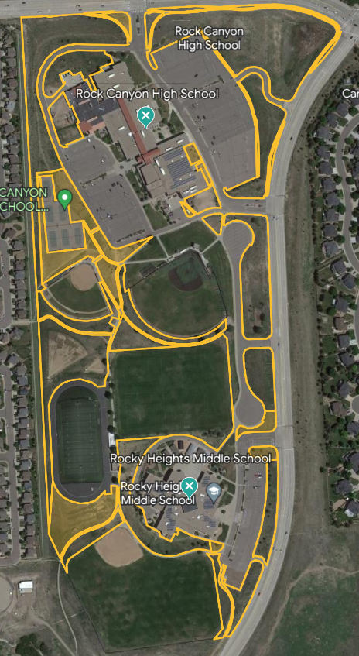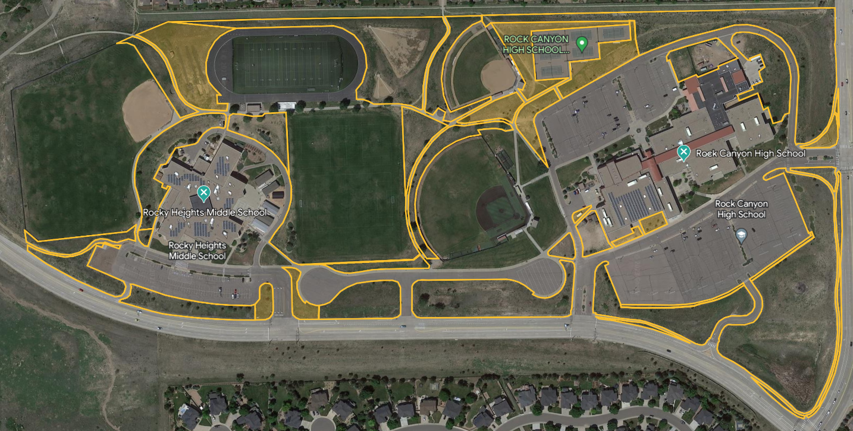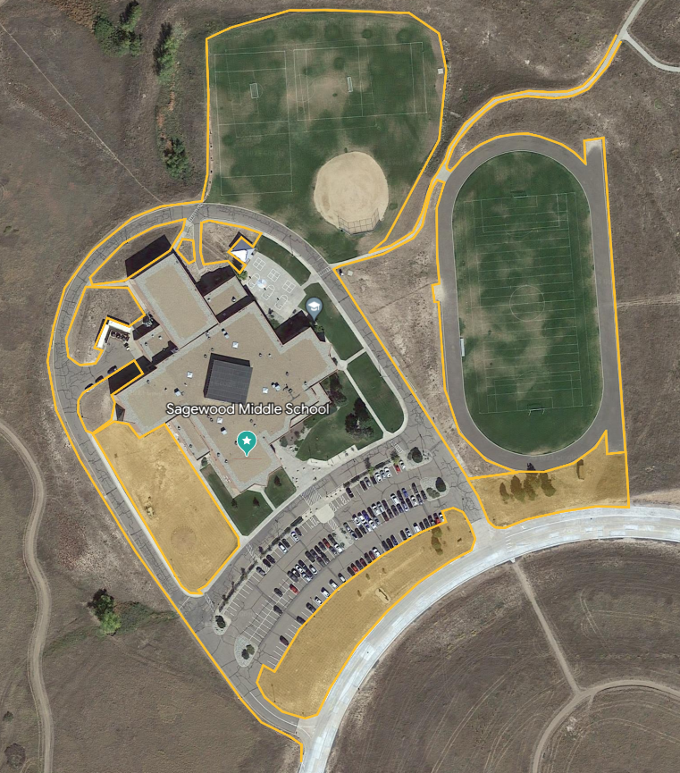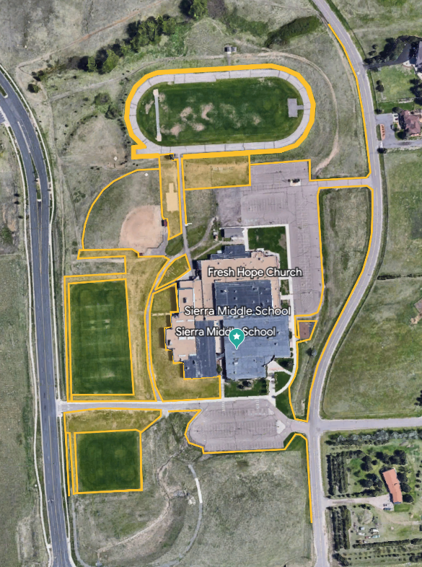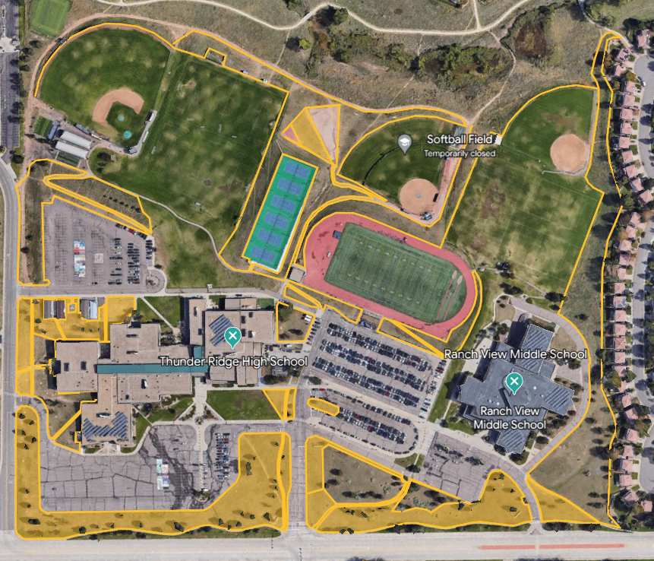

- DEFINITIONS
  - Addendum means a written modification to this RFP issued by DCSD through BidNet.
  - Contract Documents means the agreement DCSD requires the awarded Respondent to execute, together with all attachments, exhibits, and statements of work.
  - Master Agreement means the agreement attached to this RFP as Attachment A, which the awarded Respondent is required to execute.
  - Respondent means the person or entity submitting a Response. A solicitation document may refer to a Respondent as a proposer, bidder, offeror, or supplier; each such term has the meaning given to Respondent.
  - Response means the submission made by a Respondent. A solicitation document may refer to a Response as a proposal, statement of qualifications, quotation, or bid; each such term has the meaning given to Response.
  - Proposal means a Response submitted in reply to this RFP. Proposal and Response have the same meaning. Proposer and Respondent have the same meaning.

- SOLICITATION PROCESS
  - Issuance. DCSD issues solicitation documents through BidNet. Respondents are solely responsible for monitoring BidNet for Addenda and other communications relating to this RFP.
  - Questions. Questions concerning this RFP must be submitted through BidNet by the deadline stated in Section 2.0. DCSD is not obligated to respond to questions received after the deadline.
  - Addenda. DCSD may modify this RFP only by written Addendum issued through BidNet. Verbal statements and written responses not issued as an Addendum do not modify this RFP and may not be relied upon. Respondent shall acknowledge receipt of all Addenda in its Response.
  - Restricted Communications. From the date this RFP is issued until DCSD issues notice of award or cancellation, Respondent and its representatives shall not communicate regarding this RFP with any DCSD employee, officer, agent, Board member, or evaluation committee member, other than the contact identified in this RFP and through the means directed in this RFP. Violation of this Section may result in rejection of the Response.
  - Schedule. Section 2.0 states the anticipated solicitation schedule. DCSD may modify the schedule at any time by Addendum.

- PROPOSAL PREPARATION AND SUBMISSION
  - Submission. Responses must be submitted electronically through BidNet in the format required by this RFP and must be received no later than the date and time stated in this RFP.
  - Late Responses. DCSD will not accept or consider a Response received after the stated deadline. Respondent bears sole responsibility for timely submission.
  - Signature Authority. Each Response must be signed by an individual authorized to bind the Respondent, with that individual’s name and title clearly identified.
  - Validity Period. All Response contents, including pricing, shall remain valid and irrevocable for ninety (90) days following the submission deadline.
  - Modification and Withdrawal. Respondent may modify or withdraw its Response through BidNet at any time prior to the submission deadline. After the deadline, Respondent may not unilaterally modify or withdraw its Response, except as requested or permitted by DCSD.
  - Cost of Preparation. DCSD is not liable for any cost incurred by Respondent in preparing or submitting a Response, or for any work performed prior to execution of the Contract Documents.
  - Ownership of Responses. All Responses and accompanying materials become the property of DCSD upon submission.
  - Use of District Branding. A Respondent using DCSD marks or logos in its Response shall use the current brand standards published by DCSD at https://www.dcsdk12.org/about/departments/communications/branding-logos-and-templates.
  - Responsiveness. A Response that does not conform to the requirements of this RFP may be determined non-responsive and receive no further consideration. DCSD may waive or decline to waive any informality or irregularity in any Response.
- PROPOSAL FORMAT AND CONTENT
To maintain comparability in review and evaluation, proposals shall be organized in the order below. Respondents shall provide only the information requested and shall avoid promotional materials. All pages shall be consecutively numbered. A proposal that does not conform may be determined non-responsive.
  - Table of Contents. Identify all material and responses by page number, in sequential order, including enclosures.
  - Cover Letter. A brief letter stating Respondent’s understanding of the requirements and its interest in and ability to perform. The letter shall be signed by an individual authorized to bind Respondent and shall identify all persons authorized to present on Respondent’s behalf, with name, title, address, telephone, and email.
  - Qualifications and Personnel. Summarize the qualifications of the firm, including any subcontractors or subconsultants. Identify the individuals who will administer day-to-day operations of the DCSD contract, their credentials, and the percentage of the contract each is expected to perform. Include an organizational chart identifying staff responsible for contract duties. Personnel identified shall not be changed without DCSD’s prior written approval, and DCSD may terminate the resulting contract if key personnel change or the working relationship is not satisfactory. Include resumes for the personnel proposed to perform the work.
  - References. Provide three (3) references from the K-12 education market from the current calendar year or the two (2) preceding calendar years. Include customer name, address, contact name, telephone, and email. Separately, summarize all contracts of similar size and scope performed within the past three (3) years, including project name, agency, contract dates, contract value, and a contact person.
  - Response to Scope. Acknowledge agreement with each requirement in Section 4.0 or propose an alternative for DCSD to consider. Summarize Respondent’s approach, understanding of the services, and any special considerations of which DCSD should be aware. Any exception to the scope shall be identified in Attachment B.
  - Pricing. Provide pricing in the format required by this RFP. Pricing shall exclude taxes from which DCSD is exempt.
  - Exceptions. Complete and submit Attachment B, Exceptions Form, identifying every exception Respondent takes to this RFP and to the Master Agreement. Section 11.0 states how DCSD treats exceptions.
  - Debarment Certification. Complete, sign, and submit Attachment C, Certification Regarding Debarment and Suspension.
  - Appendices. Content is at Respondent’s discretion. Materials should be limited to those helpful to DCSD in understanding the goods or services proposed.

- CERTIFICATION REGARDING DEBARMENT AND SUSPENSION
  - Certification by Submission. By submitting a Response, Respondent certifies, to the best of its knowledge and belief, that neither Respondent nor its principals:
    - are presently debarred, suspended, proposed for debarment, declared ineligible, or voluntarily excluded from covered transactions by any federal, state, or local department or agency;
    - have, within the three-year period preceding submission of the Response, been convicted of or had a civil judgment rendered against them for commission of fraud or a criminal offense in connection with obtaining, attempting to obtain, or performing a public transaction or contract; violation of federal or state antitrust statutes; or commission of embezzlement, theft, forgery, bribery, falsification or destruction of records, making false statements, or receiving stolen property;
    - are presently indicted for or otherwise criminally or civilly charged by a government entity with commission of any offense described in subsection (b) above; or
    - have, within the three-year period preceding submission of the Response, had one or more public transactions terminated for cause or default.
  - Written Certification Required. Respondent shall submit with its Response the signed Certification Regarding Debarment and Suspension attached as Attachment C. Failure to submit the signed certification may render the Response non-responsive.
  - Inability to Certify. A Respondent unable to certify each statement in Section 9.1 is not eligible for award, and its Response will be rejected.
  - Continuing Obligation. Respondent shall notify DCSD in writing immediately if any certification made under Section 9.1 becomes inaccurate at any time during this solicitation or during the term of any resulting contract.

- REPRESENTATIONS AND CERTIFICATIONS
  - Independent Response. Respondent certifies that its Response was arrived at independently and without collusion with any other Respondent, and that the contents of its Response have not been and will not be disclosed to any person outside Respondent’s organization prior to the submission deadline.
  - Conflict of Interest. Respondent shall disclose in its Response any actual or potential conflict of interest, including any financial, familial, or employment relationship between Respondent or its principals and any DCSD employee, officer, or Board member. This requirement shall also apply to any subcontractors or other parties who will be participating in performing Respondent’s responsibilities.
  - Gifts and Gratuities. Respondent shall not offer or provide any gift, gratuity, favor, entertainment, kickback, or thing of value to any DCSD employee, officer, or Board member in connection with this RFP, consistent with C.R.S. § 24-18-104. Unauthorized contact with DCSD personnel regarding this RFP is prohibited and may be grounds for disqualification.
  - Public Contracts for Services. Respondent certifies that it does not knowingly employ or contract with a worker without authorization to perform work under a public contract for services, and that it will comply with C.R.S. §§ 8-17.5-101 et seq.
  - Compliance with Law. Respondent shall comply with all applicable federal, state, and local laws, regulations, and codes, and shall obtain all licenses and permits necessary to perform.
  - Non-Discrimination. DCSD affords equal opportunity in its employment, services, programs, and activities. Respondent shall not discriminate on the basis of age, race, color, national origin, sex, religion, creed, or disability. Businesses owned and operated by minorities, women, and veterans are encouraged to respond.

- CONTRACT DOCUMENTS AND EXCEPTIONS
  - Applicable Agreement. The Master Agreement is attached as Attachment A. Respondent shall review it in its entirety before submitting a Response.
  - Disclosure of Exceptions. Respondent shall submit all exceptions to the Master Agreement with its Response, using Attachment B, Exceptions Form. Each exception shall identify the section to which it applies, state the proposed alternative language, and state the basis for the exception.
  - Waiver. Exceptions not disclosed in the Response are waived. A Respondent that does not submit exceptions is deemed to accept the Master Agreement in its entirety.
  - No Obligation to Accept. DCSD is under no obligation to accept any exception. DCSD may reject a Response, in whole or in part, on the basis of exceptions taken. Material or extensive exceptions may render a Response non-responsive.
  - Execution. Award is contingent upon execution of the Contract Documents. If the awarded Respondent fails to execute the Contract Documents within the time stated by DCSD, DCSD may withdraw the award and proceed to the next Respondent or cancel this RFP.

- MINIMUM CONTRACT REQUIREMENTS
  - Application of this Section. This Section states minimum requirements applicable to any award. Where DCSD and the awarded Respondent execute Contract Documents, the Contract Documents control and supersede this Section. Where no Contract Documents are executed, this Section applies to the award and to performance thereunder.
  - Insurance. The awarded Respondent shall maintain, at its own expense, the following minimum coverages throughout the term of the award, and shall provide DCSD a certificate of insurance evidencing compliance prior to commencing performance. All policies shall be issued by carriers rated A-, Class VII or better in the most current edition of Best’s Reports. The awarded Respondent shall ensure its subcontractors maintain equivalent coverage.
    - Commercial general liability insurance with limits of not less than $1,000,000 per occurrence and $2,000,000 aggregate, including ongoing and products-completed operations and insured contract coverage, which shall be primary and noncontributory and shall not erode with costs of defense. DCSD, its officers, directors, Board of Education, and employees shall be named as additional insureds.
    - Where personnel operate vehicles on or in connection with the award, automobile liability insurance for owned, hired, and non-owned vehicles with a combined single limit of not less than $1,000,000 per occurrence, including a waiver of subrogation in favor of DCSD and naming DCSD, its officers, directors, Board of Education, and employees as additional insureds.
    - Workers’ compensation coverage as required by law. The awarded Respondent assumes full responsibility for all workers’ compensation claims arising from its performance.
  - Additional Coverages. DCSD may require additional or higher coverages in the Contract Documents or applicable statement of work based on the nature of the goods or services awarded. The coverages stated in Section 12.2 are minimums and do not limit any requirement imposed at contracting.
  - Indemnification. The awarded Respondent shall indemnify, defend, and hold harmless DCSD, its elected officials, employees, representatives, and agents from and against all claims by third parties for property damage, bodily injury, damages, liabilities, costs, expenses, and attorney fees arising out of or connected with any act or omission of the awarded Respondent, its employees, agents, subcontractors, or assignees. If the awarded Respondent is a public entity, this Section applies to the extent authorized by law and shall not be construed as a waiver of any protection under the Colorado Governmental Immunity Act.
  - Warranty. The awarded Respondent warrants that all goods, materials, and work will conform to the applicable drawings, specifications, samples, and other descriptions furnished to or by DCSD, and will be free from defects. Without limiting any right DCSD may have at law or in equity, goods that are not as warranted or that do not conform may be returned at the awarded Respondent’s expense within a reasonable time after delivery, for credit or replacement as DCSD directs.
  - Remediation. Where the awarded Respondent fails to timely remediate nonconforming goods or services after written notice from DCSD, DCSD may perform or have performed any necessary remediation and invoice the awarded Respondent for the cost, which the awarded Respondent shall pay within thirty (30) days of receipt. This right is in addition to all other remedies available to DCSD, including termination for cause.
  - Background Checks. The awarded Respondent shall conduct, at its own expense, a criminal background check for each employee who is or is reasonably likely to be in the presence of DCSD students or on DCSD property, consistent with C.R.S. § 22-32-109.8. The awarded Respondent shall not assign any employee who has been convicted of, pled nolo contendere to, or received a deferred sentence or deferred prosecution for a felony or for any crime involving unlawful sexual behavior or unlawful behavior involving children. The awarded Respondent shall complete a Verification of Background Check upon DCSD’s request.

- EVALUATION AND AWARD
  - Evaluation Committee. Proposals will be reviewed by a selection committee applying the criteria stated in Section 13.2. The committee may request clarification, additional information, presentations, interviews, or demonstrations from one or more Respondents.
  - Evaluation Criteria. DCSD will evaluate proposals against the following criteria:

Price / cost | 40% | Total cost across all sites, unit pricing for add-ons (extra cuts, cleanups), and price clarity
Qualifications and experience | 20% | Years in business, comparable contracts (size, public-sector work), and references from similar clients
Technical approach and work plan | 5% | Mowing frequency and scheduling, equipment list, crew size, how they handle seasonal peaks, trimming and edging, debris removal, and turf-health practices
Staffing and capacity | 5% | Crew supervision, backup crews, and ability to cover all sites in the required window
Quality control and responsiveness | 10% | Inspection process, complaint response time, communication and reporting, and weather-delay protocols
Safety and compliance | 20% | Safety program, incident history, employee training, and, if the sites are school properties, background checks and policies for working around students

  - Basis of Award. DCSD will award to the Respondent whose Proposal is determined most advantageous to the District, applying the criteria stated in Section 13.2. Price is a factor in every award but is not necessarily the sole determining factor. DCSD may negotiate with one or more Respondents prior to award and may award to more than one Respondent.
  - Reservation of Rights. DCSD reserves the right to reject any or all Responses; waive or decline to waive any informality or irregularity; accept all or any portion of a Response; negotiate the scope of goods or services; issue a new solicitation; withhold award; make multiple awards; and make no award.
  - Single Response. Receipt of a single Response does not require DCSD to reject it, to reissue this RFP, or to make an award. DCSD may award, reissue, or make no award.
  - Reference and Responsibility Verification. DCSD may contact any reference provided by Respondent and any other source to evaluate Respondent’s performance, qualifications, and responsibility.
  - No Guarantee of Award. Issuance of this RFP does not obligate DCSD to make any award. DCSD may decline to award, may cancel this RFP, and may obtain the goods or services by other lawful means, in each case without liability to any Respondent.
  - No Guarantee of Volume. An award does not guarantee any minimum volume of work or purchase. DCSD reserves the right to obtain the same or similar goods or services from other sources at any time.
  - Sole Responsibility and Assignment. The awarded Respondent shall be the sole point of contact and responsibility for all matters arising under the resulting contract, including payment of all charges, and shall not assign or transfer any interest in the contract without DCSD’s prior written consent.
  - Use of DCSD Contracts by Other Agencies. DCSD may extend to other governmental agencies the opportunity to purchase under any resulting contract, with the agreement of the awarded Respondent. Each participating agency establishes its own contract, issues its own orders, and makes its own payments. DCSD is not a party to and bears no liability for any agreement between the awarded Respondent and another agency.
- GENERAL CONDITIONS
  - Public Records. Responses are subject to disclosure under the Colorado Open Records Act, C.R.S. §§ 24-72-201 et seq. (“CORA”). DCSD neither requests nor encourages the submission of confidential or proprietary information. DCSD does not disclose Responses until it issues notice of award or cancels this RFP. Marking information as confidential, proprietary, privileged, or with a similar designation is not by itself sufficient to prevent disclosure. Respondent shall identify with specificity any information it asserts is exempt from disclosure and the legal basis for the assertion. DCSD determines whether information is subject to disclosure and is not liable for any disclosure made in accordance with CORA. A Response in its entirety, and pricing information, will not be treated as confidential or proprietary.
  - Governing Law and Venue. Colorado law governs this RFP. Venue for any action arising out of or related to this RFP, a Response, or work performed thereunder lies exclusively in the District Court in and for Douglas County, Colorado.
  - Tax Exemption. DCSD is exempt from federal excise tax and Colorado sales and use taxes. A certificate of exemption is available upon request. Taxes shall not be included in pricing. Any applicable tax shall be shown as a separate line item.
  - Non-Appropriation. All DCSD obligations are subject to annual appropriation of funds. DCSD is not obligated beyond the funds appropriated for the then-current fiscal year, and any resulting contract may be terminated without penalty upon thirty (30) days written notice if funds are not appropriated for a subsequent fiscal year.
  - Governmental Immunity. Nothing in this RFP or any resulting contract waives, limits, or otherwise modifies any protection available to DCSD under the Colorado Governmental Immunity Act, C.R.S. §§ 24-10-101 et seq.
  - Cancellation. DCSD may cancel this RFP, in whole or in part, at any time and without liability to any Respondent.
  - No Contract Formed. No contract exists between DCSD and any Respondent unless and until the Contract Documents are executed by both parties.

- ATTACHMENTS
The following attachments are incorporated into and form a part of this RFP:
Attachment | Document
A | DCSD Master Services Agreement (MSA Rev 6)
B | Exceptions Form (RFP and Master Agreement)
C | Certification Regarding Debarment and Suspension (form)
DCSD may issue one or more additional documents with this RFP, including pricing schedules, specifications, or other reference materials. Any such document is incorporated into and forms a part of this RFP.
ATTACHMENT A

MASTER SERVICES AGREEMENT

between
Douglas County School District RE-1 and

THIS MASTER SERVICES AGREEMENT (the “Agreement”) is made and entered into as of the last signature below, (the “Effective Date”), by and between Douglas County School District RE-1 ("DCSD”), located at 701 Prairie Hawk Drive, Castle Rock, Colorado 80109, and
, (“Supplier”), having a place of business at
. DCSD and Supplier are each hereinafter referred to individually as a “Party” or collectively as the “Parties.”
NOW, THEREFORE, for good and valuable consideration, the receipt and sufficiency of which are hereby acknowledged, and intending to be legally bound, the Parties agree as follows:

1.0 DEFINITIONS
Unless and except to the extent otherwise defined in the relevant provisions of the Agreement or any Statement of Work (“SOW”), all capitalized terms shall have the meanings assigned to them below (equally applicable for singular and plural forms of the terms defined):
  - Acceptance Criteria means the requirements set forth in the SOW used to measure the completeness or adequacy of the Deliverables. If no requirements measuring the completeness or adequacy of Deliverables appear in the SOW, Acceptance Criteria means the point at which Deliverables are functionally complete such that DCSD can realize their beneficial and intended use.
  - Affiliate means, with respect to a Party, any other entity controlling, controlled by, or under common control with such Party at the time in question.
  - Change Order means a written agreement signed by the Parties that modifies the SOW term, SOW price, or the kind and character of Services and Deliverables under an SOW.
  - Confidential Information means any information disclosed by one party to the other that is understood by the Parties to be confidential, designated in writing by one of the Parties as confidential, or otherwise designated as confidential under this Agreement. All information prohibited from release by applicable federal or state law, including FERPA, the Colorado Student Data Protection Act, and the Government Records Management Act, constitutes Confidential Information. Information that is or becomes publicly available through no breach of this Agreement, or that was already in the recipient Party’s possession at the time of the tendering Party’s disclosure is not Confidential Information. Disclosure required under the Colorado Open Records Act,
C.R.S. §§ 24-72-201, et seq., (“CORA”) does not constitute a breach of this Agreement.
  - Data Security Incident means any actual or reasonably suspected unauthorized access to, acquisition of, use, disclosure, or destruction of DCSD’s Confidential Information or Student PII.
  - Deficiency means any material defect in a Deliverable that fails to substantially comply with the applicable Acceptance Criteria or requirements set forth in this Agreement or an SOW.
  - Deliverable means any Product or Service produced or performed by Supplier and required to be delivered to DCSD.
  - Fees shall mean the amounts payable by DCSD to Supplier for Deliverables.
  - Material Defect means a Deficiency in any Deliverable that fails to substantially comply with the applicable Acceptance Criteria.
  - Services shall mean collectively the services to be provided by Supplier to DCSD pursuant to this Agreement and any applicable SOW.
  - Statement of Work (“SOW”) means a written document specifying the terms by which Supplier will provide Services to DCSD. An SOW may take the form of a purchase order, order form, service order, quote, or other written agreement between the Parties.

2.0 DELIVERABLES
  - Scope of Deliverables. Supplier shall furnish Deliverables to DCSD in accordance with and subject to the terms and conditions of this Agreement and one or more consecutively numbered SOW’s incorporating this Agreement.
Where an engagement involves Deliverables including Products and technology Services, the terms of this Agreement apply to both unless otherwise specified in the applicable SOW.

SOW Requirements.
    - Supplier shall not furnish Deliverables unless and until authorized through an SOW. Each SOW shall be deemed to incorporate all of the terms and conditions set forth in this Agreement; however, in the case of conflict between the terms of a SOW and this Agreement, the terms of this Agreement shall control, but only for the duration of and only with respect to the Services performed under that particular SOW.
    - Each SOW shall contain, at a minimum, the following information:
      - The term of the SOW;
      - A description of the SOW Deliverables;
      - SOW Acceptance Criteria; and
      - SOW Price broken down into a Schedule of Values.
  - Change Order Process. Either Party may request a modification of the character, kind and scope of the Supplier’s Deliverables, SOW Price, and Substantial Completion Date by submitting to the other a Change Order request. Change Orders must be in writing, executed by both Parties, to be effective. Supplier shall not be entitled to any compensation for Deliverables outside the scope of an SOW unless performed pursuant to a Change Order. DCSD is legally barred from assuming any financial liability for additional work under an SOW outside an approved Change Order where DCSD certifies that it has the secured funds required for the Change Order.
  - Required Resources and Compatibility. Except as otherwise expressly provided in an SOW, Supplier shall be responsible for providing the facilities, personnel, equipment, software, technical knowledge, and other resources necessary to provide the Deliverables. DCSD may request that the Supplier reassign personnel not compatible with DCSD’s expectations.

Compliance with Accessibility Standards.
Supplier shall comply with all applicable technology accessibility standards for individuals with disabilities, including those established by the Colorado Governor’s Office of Information Technology (OIT) and required under Colorado law, including HB21-1110 and SB23-244 (C.R.S. §§ 24-34-301, 24-34-802, 24-
37.5-106, 24-85-101, and 24-85-103 et seq.), as amended from time to time. Current OIT standards are published at https://oit.colorado.gov/standards-policies-guides.
Supplier warrants that its Deliverables comply with these standards. Supplier shall, upon DCSD’s request, provide current accessibility testing results dated within the previous twelve (12) months verifying compliance. Supplier shall promptly remediate any confirmed noncompliance at no cost to DCSD within a timeframe agreed to by the Parties.
In accordance with C.R.S. § 22-1-135(2)(d)(IV), Supplier shall indemnify, defend, and hold harmless DCSD, its employees, and agents from all costs, damages, and legal claims arising from Supplier’s noncompliance with applicable accessibility standards. Failure to comply with this section constitutes a material breach and grounds for termination for cause.
  - Student Personal Information. All Deliverables involving Student Personally Identifiable Information (“PII”) must be performed in compliance with applicable federal and state law, including FERPA and the Colorado Student Data Protection Act.
  - Subcontractors. Subject to the prior written consent of DCSD, Supplier may delegate to subcontractors such duties as Supplier deems necessary. Supplier shall be responsible to DCSD for the completion of all work by subcontractors and full payment of all charges by such subcontractors.
  - Time is of the Essence. Supplier acknowledges that time is of the essence in the performance of its obligations under this Agreement.

Background Check Certification.
    - Supplier shall conduct, at its own expense, a criminal background check for each employee who is or is reasonably likely to be in the presence of DCSD students or on DCSD property.
    - Background report updates may be requested by DCSD. Upon any reasonable notice, Supplier agrees to conduct an updated criminal background check for any employee meeting the criteria set forth in Section 2.9.1.
    - Supplier agrees not to assign any employee to perform Services for DCSD who has been convicted of, pled nolo contendere to, or received a deferred sentence or deferred prosecution for any crime involving unlawful sexual behavior or unlawful behavior involving children.
    - DCSD reserves the right to cancel at any time, without penalty, this Agreement if it determines the Supplier violated any part of this Section 2.9.
  - Debarment and Suspension. Supplier represents and warrants:
- that it is not presently debarred, suspended, proposed for debarment, declared ineligible, or voluntarily excluded from a covered transaction involving any federal, state, or local government entity within the preceding three years;
- that it and its principals have not been convicted of or had a civil judgment rendered against it for fraud, criminal offense, antitrust violation, embezzlement, theft, forgery, bribery, falsification or destruction of records, false statements, or receiving stolen property in connection with a public transaction;
- is not presently indicted or charged by any government entity for any such offense; and
- has not had a public transaction terminated for cause or default within the preceding three years.
  - FERPA. Supplier shall comply with all applicable provisions of the Family Educational Rights and Privacy Act of 1974, 20 U.S.C. § 1232g (“FERPA”), and all regulations promulgated thereunder. All PII is Confidential Information and shall not be released or disclosed without DCSD's prior written authorization.
  - Data Security and Breach Notification. Supplier shall maintain reasonable technical, administrative, and physical safeguards to protect DCSD’s Confidential Information and PII from unauthorized access, use, or disclosure.
Upon discovery of a Data Security Incident, Supplier shall notify DCSD in writing within forty-eight (48) hours, including a description of the incident, data affected, and
remediation steps taken in accordance with C.R.S § 6-1-716. Supplier shall cooperate with DCSD’s investigation and bear all reasonable costs of notification, remediation, and required regulatory reporting.
Supplier’s obligations under this Section survive termination of this Agreement for three (3) years.

3.0 TERM OF AGREEMENT AND SOW
  - Agreement Term. The term of this Agreement shall begin on the Effective Date and shall continue until terminated in accordance with Section 11.0 (Termination).
  - SOW Term. The term of an SOW shall be as set forth in the applicable SOW unless earlier terminated in accordance with this Agreement. In the event the term of the SOW runs but the Parties continue to do business without any further written agreement, the SOW shall be deemed to have continued on a month-to-month basis, subject to all applicable terms and conditions therein.

CONFLICT OF INTEREST FORBEARANCE
DCSD expressly reserves the right to contract with others to obtain Deliverables similar or identical to those provided by Supplier, and Supplier expressly reserves the right to contract with others to provide Deliverables similar or identical to those provided to DCSD, provided, however, that Supplier shall not engage in any work that creates a Conflict of Interest with DCSD.

ACCEPTANCE AND REJECTION OF DELIVERABLES
  - DCSD may review, analyze, and test any Deliverable or Service to confirm compliance with the Acceptance Criteria or other requirements set forth in this Agreement or the applicable SOW. If DCSD identifies a Deficiency, DCSD will notify Supplier in writing within sixty (60) days of the date DCSD discovered, or reasonably should have discovered, the Deficiency.
Upon receipt of notice, Supplier shall cure the Deficiency at its own expense within ten
(10) calendar days, or such other period as the Parties mutually agree in writing. If Supplier fails to timely cure, DCSD may, in its sole discretion:
- Terminate this Agreement or the applicable SOW for material breach, in which case DCSD shall have no payment obligation for the uncured Deficiency; or
- Correct the Deficiency itself or through a third party, the cost of which DCSD may deduct from payments due to Supplier, or if no payment is due, DCSD may claim such costs as damages; or
- Reject the Deliverables and purchase comparable goods under a right to cover or otherwise, the cost of which DCSD may deduct from payments due Supplier, or if no payment is due Supplier, DCSD may claim the cost as damages.
  - The remedies set forth in this Section are cumulative and do not limit DCSD's rights under Section 11.0 (Termination).

COMPENSATION
DCSD shall pay Supplier as set forth in an SOW for Deliverables furnished. Supplier shall aggregate the cost of Deliverables for purposes of tier or volume pricing. DCSD shall not be billed for any Fees not expressly set forth in an SOW or this Agreement.

INVOICING AND PAYMENTS
  - Invoicing. In addition to those requirements under this Agreement’s SOW, Supplier shall invoice DCSD monthly and include any applicable credits accrued to date. For time-and-materials engagements under a guaranteed maximum price or fixed fee engagement, invoices shall include a summary description of Deliverables rendered itemized by labor category including daily hours worked under each such category. For any Products furnished, the invoice shall include a summary of each category of Product furnished along with the cost and quantity of the Product furnished in each category. DCSD reserves the right to request reasonable supporting documentation for any invoice.
  - Payment Terms. All invoices are due and payable by DCSD net thirty (30) days from the date of receipt by DCSD. All invoices and payments shall be in U.S. dollars.
    - Supplier may elect to offer DCSD a 2% prompt payment discount for invoices paid within fifteen (15) business days of receipt. Such election is documented at execution.
  - Disputed Amounts. DCSD shall notify Supplier in writing within thirty (30) days of invoice receipt of any disputed amounts (the “Dispute Notice”). Only disputed amounts may be withheld pending resolution. The Parties shall negotiate in good faith to resolve disputes promptly. If resolved, DCSD shall pay, or Supplier shall issue a credit memo within twenty (20) days of resolution. If unresolved after sixty (60) days, either Party may invoke Section 9.0, Dispute Resolution.
  - Taxes. Supplier is responsible for all taxes, levies, and government-imposed obligations arising from its business operations and income. Supplier shall not invoice DCSD for any taxes, levies or other government-imposed obligation for which DCSD is exempt.
  - Prompt Payment Discount Election. By initialing below, Supplier agrees to accept a 2% discount on all invoices paid by DCSD within fifteen (15) business days of receipt. This discount will be applied automatically upon early payment. See Section 7.2.1.
Supplier Initial: Date:

CONFIDENTIALITY
  - Use of Confidential Information. Supplier shall use DCSD’s Confidential Information solely to furnish Deliverables under this Agreement and shall bind its employees, agents, and subcontractors to the same obligation. All Confidential Information remains DCSD’s sole property and shall be returned or destroyed upon termination or expiration of this Agreement, or upon Supplier’s determination that it no longer requires such information. Upon request, Supplier shall certify in writing that
all Confidential Information has been returned or destroyed. The obligations of this Section survive termination.
  - Publicity. A Party may not use the other Party’s name, logo, or mark without prior written approval. The Parties shall not communicate with members of the media or otherwise make any public announcements regarding the Deliverables, or the terms or existence of this Agreement, without the other Party’s prior written consent. DCSD’s disclosure of the terms of this Agreement pursuant to CORA is not a violation of this Section 8.2.

DISPUTE RESOLUTION
If a dispute arises under this Agreement, each Party shall designate a representative to meet within ten (10) business days of written notice and negotiate in good faith toward resolution. If unresolved, the Parties shall, within five (5) business days, jointly prepare a written position statement summarizing unresolved issues and proposed resolutions for review by each Party’s senior executive, who shall have five (5) business days to resolve the matter. If the dispute remains unresolved, either Party may pursue all remedies available at law or in equity.

GOVERNING LAW
This Agreement and any related SOW is governed by the laws of the State of Colorado, without regard to principles of conflict of laws. This Agreement shall be deemed to be made and executed in the State of Colorado. The Parties agree that any legal action by either Party to enforce any rights hereunder shall be brought in the United States District Court for the District of Colorado or Colorado State District Court for the County of Douglas.

TERMINATION
  - Termination for Convenience by DCSD. DCSD may terminate this Agreement or any SOW for convenience upon giving Supplier thirty (30) days’ prior written notice. In such an event, Supplier shall be entitled to payment as described in Section 11.4.2. In no event will DCSD be liable for any exit or termination fee. Where Supplier has engaged subcontractors or other agents to furnish Deliverables under this Agreement, Supplier shall provide DCSD with evidence that all such parties have been paid for work completed to the date of termination.
  - Termination for Breach. Either Party may terminate this Agreement or any SOW upon written notice if the other Party materially defaults on any obligation under this Agreement and fails to cure such default within thirty (30) days’ written notice. Termination is immediate and without cure period or notice when a Party becomes unable to pay its debts as they become due or becomes subject to voluntary or involuntary bankruptcy or insolvency proceedings not dismissed within forty-five (45) days.
  - Termination for Non-Appropriation of Funds. DCSD may terminate this Agreement or any SOW if funds are not allotted for the next fiscal year to continue this Agreement. DCSD may also affect such termination by giving the Supplier written notice of its intention to terminate not less than thirty (30) days prior to the end of the then current fiscal period, stating the reason for termination is non-appropriation of funds. Upon termination of this Agreement as provided in this paragraph, DCSD shall not be
responsible for the payment of any Deliverables beyond those that DCSD has accepted and appropriated funds.

Procedure upon Termination.
    - Upon termination of this Agreement, Supplier shall promptly return to DCSD, or destroy, as DCSD may direct, all DCSD property and Confidential Information in Supplier’s possession which destruction shall be certified to DCSD in writing.
    - Except as provided in Section 11.3, if DCSD terminates this Agreement for any reason other than Supplier’s uncured breach, Supplier shall be entitled to payment for Deliverables furnished and accepted by DCSD as well as reasonable expenses incurred up to the date of termination.

INSURANCE
Supplier shall maintain, at its own expense, the insurance coverages described in this Section throughout the term of this Agreement and shall provide DCSD a certificate of insurance within fifteen (15) days of the Effective Date demonstrating compliance with these coverage requirements. Supplier may obtain insurance coverage in excess of the limits set by this Section
12.0 at Supplier’s own expense. Supplier shall ensure subcontractors maintain equivalent coverage. All policies shall be issued by carriers rated A-, Class VII or better in the most current edition of Best’s Reports.
  - Commercial General Liability Insurance – Supplier shall maintain commercial general liability insurance with limits of not less than $1,000,000 per occurrence and
$2,000,000 aggregate, including ongoing and products-completed operations, insured contract coverage, and which shall be primary and noncontributory. DCSD, its officers, directors, board of education, and employees shall be named as additional insureds. Supplier shall provide written notice to DCSD prior to cancellation or non-renewal. General liability insurance shall not erode with costs of defense.
  - Automobile Liability Insurance – Where Supplier personnel operate vehicles on or in connection with Deliverables, Supplier shall maintain automobile liability insurance for owned, hired, and non-owned vehicles with a combined single limit of not less than
$1,000,000 per occurrence. Policies shall include a waiver of subrogation in favor of DCSD and name DCSD, its officers, directors, board of education, and employees as additional insureds.
  - Worker’s Compensation Coverage - Supplier shall comply with all applicable workers' compensation, occupational disease, and occupational health and safety laws and regulations. Supplier assumes full responsibility for all workers' compensation claims arising from furnishing Deliverables under this Agreement.
  - Additional Coverages. See the SOW for any additional insurance coverage required.

INDEMNITY
Supplier shall indemnify, defend, and hold harmless DCSD, its elected officials, employees, representatives, and agents against all claims by third parties for property damage, bodily injury, damages, liabilities, costs, expenses, and attorney fees arising out of or connected with any act or
omission of Supplier, its employees, agents, subcontractors, or assignees under this Agreement or its SOW. If Supplier is a public entity, this Section applies to the extent authorized by law and shall not be construed as a waiver of any protections under the Colorado Governmental Immunity Act.

FORCE MAJEURE
Neither Party shall be liable for delay or failure in performance of this Agreement caused by events beyond its reasonable control, including natural disasters, extreme weather, fire, explosion, flood, public health emergencies, acts of terrorism, war, cyberattacks by third parties, or action or inaction of governmental authorities (“Force Majeure Event”). Force Majeure does not include: (a) any event Supplier could reasonably have prevented through quality assurance, disaster recovery, or other testing required or necessary to provide the Deliverables; or (b) any event where Supplier could have prevented a degradation of Deliverables through a reasonable workaround.
Either Party whose performance is prevented or delayed by a Force Majeure Event (the “Affected Party”) shall provide written notice to the other Party within five (5) business days of the Force Majeure Event or when a Party determines that a Force Majeure Event will impact its performance under this Agreement or any related SOW. Such notice shall describe the nature of the Force Majeure Event and its anticipated impact on the Affected Party’s performance including any changes needed in the term of this Agreement or any of its corollary SOW’s. The Parties shall promptly confer in good faith to mitigate the effects of the Force Majeure Event. The Affected Party shall use commercially reasonable efforts to resume performance of this Agreement if possible. If a Force Majeure Event prevents or materially delays Supplier’s performance for five
(5) or more business days, DCSD may terminate this Agreement immediately upon DCSD’s written notice.

REPRESENTATIONS AND WARRANTIES
Supplier represents and warrants that:
- the individual signing this Agreement has the legal authority to contractually bind Supplier;
- it is fully qualified, licensed where required, and experienced to furnish the Deliverables;
- the Deliverables will be furnished in a professional non-negligent manner consistent with applicable industry standards, codes, regulations or laws;
- the Deliverables will comply with all requirements set forth in this Agreement and the applicable SOW; and
- performance of this Agreement does not conflict with any other Supplier obligation.
Additional warranties specific to an engagement, including performance standards, service levels, and Deliverable specifications, shall be set forth in the applicable SOW.

IMMUNITIES
Notwithstanding anything herein to the contrary, no term or condition shall be deemed a waiver, express or implied, of any provision of the Colorado Governmental Immunity Act C.R.S. §24-10-101, et seq.

FUND AVAILABILITY
All obligations of DCSD under this Agreement or any SOW are subject to annual approval and/or budgeting and appropriation by DCSD. DCSD will not and cannot commit to any obligation under this Agreement or any of its SOW’s for which funds have not been appropriated in any given fiscal year.

WAIVERS AND AMENDMENTS
Waiver of any default shall not constitute waiver of any other default. No provision of this Agreement may be waived, amended, or modified except in writing signed by an authorized representative of each Party.

SEVERABILITY
If any provision of this Agreement is held invalid or unenforceable, the remaining provisions shall continue in full force and effect.

SURVIVAL
The following provisions survive termination or expiration of this Agreement: Section 2.5 Compliance with Accessibility Standards, Section 2.12, Data Security and Breach Notification; Section 4.0 Conflict of Interest Forbearance, Section 5.0 Acceptance and Rejection of Deliverables; Section 8.0, Confidentiality; Section 9.0, Dispute Resolution; Section 10.0, Governing Law; Section 13.0, Indemnity; Section 15.0, Representations and Warranties; Section
18.0 Waivers and Amendments; Section 25.0, Compliance with Laws, and Section 26.0, Notices.

ASSIGNMENT
This Agreement binds the Parties and their permitted successors and assigns. Neither Party may assign its rights or delegate its duties without the prior written consent of the other Party.

ENTIRE AGREEMENT; MODIFICATIONS
This Agreement, together with any SOW’s, constitutes the entire agreement between the Parties and supersedes all prior agreements, representations, and understandings, whether written or oral including any of Supplier’s terms and conditions. This Agreement may be modified only in writing signed by both Parties.

FURTHER ASSURANCE
The Parties shall execute and deliver such further documents and instruments and perform such further acts as may be reasonably required to carry out the intent and purposes of this Agreement.

NO PRESUMPTION AGAINST DRAFTER
This Agreement shall be deemed to have been drafted by both Parties and, in the event of a dispute, shall not be construed against either Party. Each Party acknowledges that it has had the opportunity to consult with counsel of its own choosing prior to entering into this Agreement.

COMPLIANCE WITH LAWS
Each Party shall comply with all applicable federal, state, and local laws, ordinances, rules, and
regulations in the performance of its obligations under this Agreement.

NOTICES
All notices under this Agreement shall be in writing and deemed duly given when delivered in person, deposited in the United States mail postage prepaid with return receipt requested, or sent by email with confirmation of receipt, addressed as follows:
Notice to Supplier:

Supplier Name:
Attention:
Title:
Telephone:
Address:
City, State, Zip:
Email:

Notice to DCSD:

Name: | Douglas County School District RE-1
Attention: | Strategic Sourcing & Contract Management
Telephone: | 720-433-0060
Address: | 701 Prairie Hawk Drive
City, State, Zip: | Castle Rock, CO 80109
Email: | StrategicSourcing@dcsdk12.org
The notice addresses may be changed by written notice given by one Party to the other in accordance with this Section.

PRIORITY OF INTERPRETATION
In the event of conflict between this Agreement and any Supplier forms, this Agreement controls regardless of any statement to the contrary in such Supplier forms.
[Remainder of Page Intentionally Left Blank - Signatures Continued on Next Page]
IN WITNESS WHEREOF, the Parties have caused this Agreement to be executed by their duly authorized representatives as of the Effective Date.

DOUGLAS COUNTY SCHOOL DISTRICT RE-1

Signature:

Name: Debra Jones

Title: Director, Sourcing & Contract Management

Date:

SUPPLIER

Signature:

Name:

Title:

Date:

ATTACHMENT B

EXCEPTIONS FORM

Respondent shall identify below every exception it takes to this RFP and to the Master Agreement, attached as Attachment A. Exceptions not identified in this form are waived. DCSD is under no obligation to accept any exception, and material or extensive exceptions may render a proposal non-responsive. Attach additional pages in this format if needed.
RFP Number: Respondent:
PART 1 — EXCEPTIONS TO THIS REQUEST FOR PROPOSAL
Identify any exception to the scope, requirements, or submission provisions of this RFP.

Section | Proposed Alternative Language | Basis for Exception
Check here if Respondent takes no exception to this RFP:
PART 2 — EXCEPTIONS TO THE MASTER AGREEMENT
Identify any exception to the Master Agreement attached as Attachment A. A Respondent that submits no entry below is deemed to accept the Master Agreement in its entirety.

Section | Proposed Alternative Language | Basis for Exception
Check here if Respondent takes no exception to the Master Agreement:
Submitted by: Title:
Firm: Date:

ATTACHMENT C
CERTIFICATION REGARDING DEBARMENT AND SUSPENSION

The Respondent to this RFP certifies, to the best of its knowledge and belief, that neither Respondent nor its principals:
- are presently debarred, suspended, proposed for debarment, declared ineligible, or voluntarily excluded from covered transactions by any federal, state, or local department or agency;
- have, within the three-year period preceding submission of the Response, been convicted of or had a civil judgment rendered against them for commission of fraud or a criminal offense in connection with obtaining, attempting to obtain, or performing a public transaction or contract; violation of federal or state antitrust statutes; or commission of embezzlement, theft, forgery, bribery, falsification or destruction of records, making false statements, or receiving stolen property;
- are presently indicted for or otherwise criminally or civilly charged by a government entity with commission of any offense described in subsection (b) above; or
- have, within the three-year period preceding submission of the Response, had one or more public transactions terminated for cause or default.
A Respondent unable to certify each statement above is not eligible for award, and its Response will be rejected.
Respondent shall notify DCSD in writing immediately if any certification made above becomes inaccurate at any time during this solicitation or during the term of any resulting contract.

Signature of Official: Name (typed): Title:
Firm:
Date:

